Spring Boot REST API – Task 2: Static Country Service (/country)

✅ Objective
Create a REST API using Spring Boot that returns the details of India by reading a bean from the Spring XML configuration (country.xml).

📘 Scenario
- Method: GET
- URL: http://localhost:8083/country
- Output: JSON object for India
- Source: Spring XML bean with id="in"

🧾 Controller: CountryController.java
package com.cognizant.spring_learn.controller;

import com.cognizant.spring_learn.Country;
import org.slf4j.Logger;
import org.slf4j.LoggerFactory;
import org.springframework.context.ApplicationContext;
import org.springframework.context.support.ClassPathXmlApplicationContext;
import org.springframework.web.bind.annotation.GetMapping;
import org.springframework.web.bind.annotation.RestController;

@RestController
public class CountryController {

private static final Logger LOGGER = LoggerFactory.getLogger(CountryController.class);

@GetMapping("/country")
public Country getCountryIndia() {
LOGGER.info("START - getCountryIndia");

ApplicationContext context = new ClassPathXmlApplicationContext("country.xml");
Country country = (Country) context.getBean("in");

LOGGER.info("END - getCountryIndia");

return country;
}
}

Screenshots
- Browser :
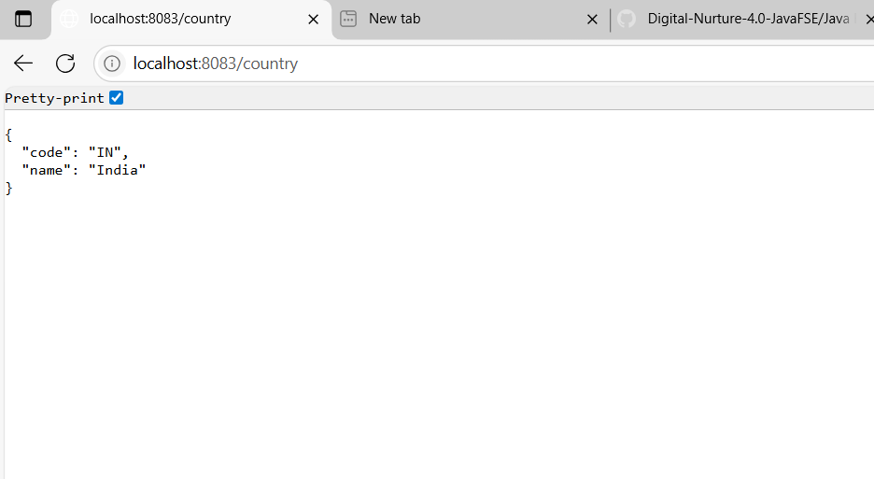
- Console logs showing:
